## Density Based Traffic Signal using Image Processing

Ajinkeya Chitrey 1, Viren Baria 1, Dhruv Kadakia 2, Dhanam Parekh 2, Yukti Bandi 3

1. 3rd Year U.G. student, Electronics and Telecommunication Department, DJSCOE, Vile-Parle (W), Mumbai –400056.

2. 2nd Year U.G. student, Electronics and Telecommunication Department, DJSCOE, Vile-Parle (W), Mumbai –400056.

3. Asst. Professor, Electronics and Telecommunication Department, DJSCE, Vile-Parle (W), Mumbai – 400 056.

#### **Abstract—Due to the increase in the number of vehicles day by day, traffic congestions and traffic jams are very common. One method to overcome the traffic problem is to develop an intelligent traffic control system which is based on the measurement of traffic density on the road using real time image processing techniques. The theme is to control the traffic by determining the traffic density on each side of the road and control the traffic signal intelligently by using the density information. The density counting algorithm works by comparing the real time frame of live video by the reference image and by searching vehicles only in the region of interest (i.e. road area). The computed vehicle density can be compared with other direction of the traffic in order to control the traffic signal smartly. In this method, a camera module is used in each stage of the traffic light in order to take pictures of the roads where traffic is bound to occur. Density of vehicles in these images is calculated using image processing tools in Matlab and different timings are allocated according to the count along with a green signal for vehicles to pass. In the proposed prototype, the red, yellow and green signals are represented using LEDs .**

#### **Keywords—Traffic density count, image processing, camera module, Arduino UNO, MATLAB, timer, LEDs.**

# **INTRODUCTION**

#### Traffic congestion is a common problem that has arisen due to the increased number of vehicles on the road. In order to deal with this problem, researchers have proposed many solutions. One of the currently used models is the timer model. Traffic can be controlled to a great extent by using timers at each phase of the traffic. Another model used is with the help of electronic sensors which detects the presence of vehicles, and produce appropriate signals. The cause of traffic is dependent on many factors like peak time, special days, season, bad weather, or unexpected events like accidents, special events or constructional activities.

#### Once we get stuck in traffic, we may have to wait for hours to get out of it. We can solve this problem to a great extent by implementing this density based traffic control system using image processing which continuously manages the traffic lights based on traffic. Our project includes interfacing of camera module, image processing system and LED’s to Arduino microcontroller. The project can be divided into three phases.

#### Phase 1 includes interfacing the camera module with Arduino microcontroller and storing the image in computer. In phase 2, the image processing is performed on the stored images and density of vehicles in a lane is calculated. Phase 3 includes allocation of timers to each signal based on the density of vehicles in that lane.

We have used CMOS OV7670 Camera Module to capture grayscale images and they are sent to the Computer through Arduino UNO microcontroller. Image processing is performed on the images using MATLAB R2015b. Then, the output signals are shown using LED’s (Red, Yellow, Green) using Arduino UNO.

# **METHODOLOGY**

1. We have a reference image and the image to be matched is continuously captured using a camera that is installed at the junction.
2. The images are pre-processed in two steps:

* Images are relocated to 300x300 pixels.
* Then the above rescaled images are converted from RGB to gray.

1. Edge detection of pre-processed images is carried out using Canny edge detection technique.
2. The output images of previous step are matched using pixel to pixel matching technique.
3. After matching the timing allocation is done depending on the percentage of matching as-

* If matching is between 0 to 30% - green light is on for 90 seconds.
* If matching is between 30 to 50% - green light is on for 60 seconds.
* If matching is between 50 to 70% - green light is on for 30 seconds.
* If matching is between 70 to 90% - green light is on for 20 seconds.
* If matching is between 90 to 100% - red light is on for 90 seconds.

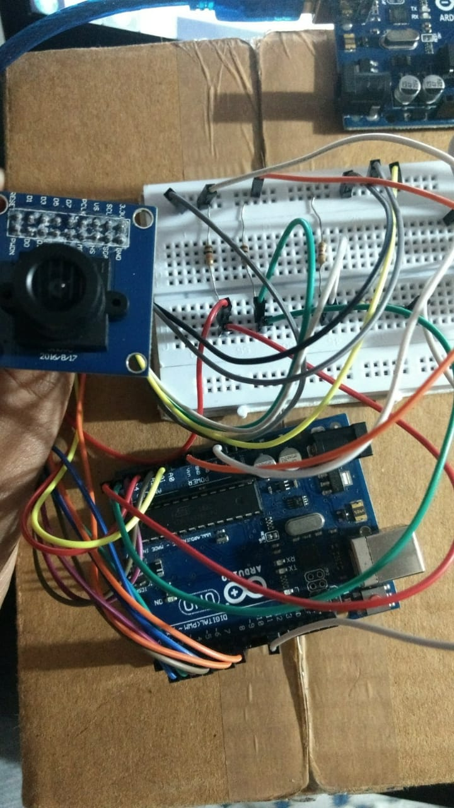

Fig 1. Interfacing OV7670 Camera with Arduino UNO

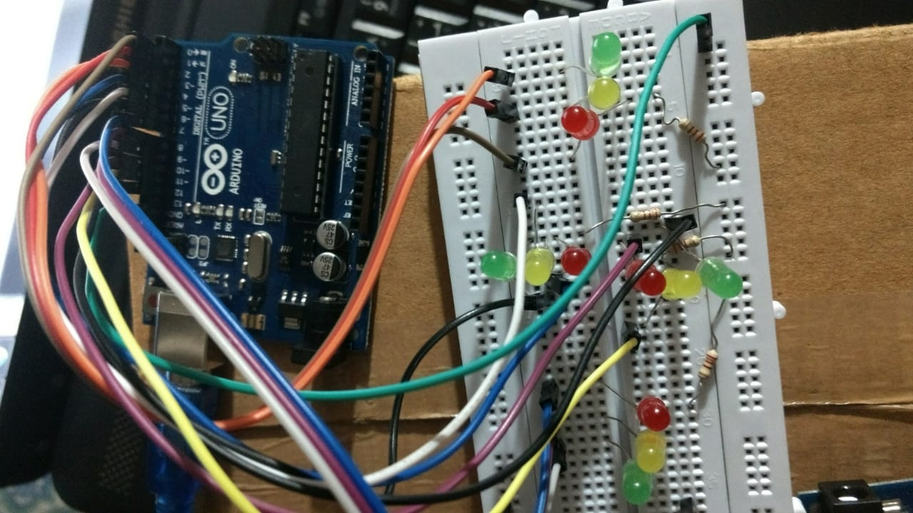

Fig 2. 4-way Traffic Signal Simulation using Arduino UNO

# **DESCRIPTION**

* Hardware Module.

A CMOS OV7670 camera module captures images of the traffic on road. The hardware module consists of an Arduino board used to control LEDs representing the red, yellow and green lights.

* Software Module.

MATLAB version R2015b is used as the image processing software which comprises specialized modules that perform specific tasks. MATLAB coding is completed using the reference and captured images.

* Image Acquisition.

A 2-D image is captured using camera module of Arduino Uno which live captures the image of road and vehicles in front of it and f(x,y) is amplitude of image or gray level at coordinate (x,y) of image. f(x,y) is positive finite valued.

* Image Resizing.

Images are resized so as to make resolution compatible for all camera specifications.

* RGB to GRAY Conversion:

Humans perceive color images in RGB format. To convert this RGB image to grayscale we have to consider RGB value of each pixel and make output as a single value reflecting brightness of that pixel.

The grayscale pixel values are expressed as: Grayscale pixel= 0.3R + 0.59G + 0.11B

* Image Enhancement:

Image Enhancement is done to adjust digital images so that results are more suitable for display and analysis for example reducing noise in the image to make it easier to identify key characteristics. In poor contrast images the adjacent characters merge during binarization. To reduce spread of characters we use POWER LAW TRANSFORMATION to increase contrast between characters. The basic law is: s=cry where r and s are input and output intensities respectively c and y are positive constants. In our project we fix c=1 and vary y(gamma) between 1&5 so that there is no spread in image after binarization.

* Image Matching:

We use a reference image and match it pixel by pixel with the real time image captured. Reference image is stored in matrix form in memory and real time image is also converted to desired matrix. For images to be same their pixel values in matrix must be same which is called pixel matching. If there is any mismatch in pixel value it adds on to the counter and used to calculate number of pixel mismatches which is expressed as:

% Match = $\frac{ No. of pixels matched sucessfully}{Total no.of pixels}$

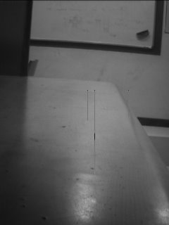 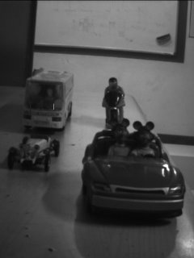Fig 3. Reference image (L) and Traffic image (R)

The percentage match of the above traffic image with the reference image is 8%.

 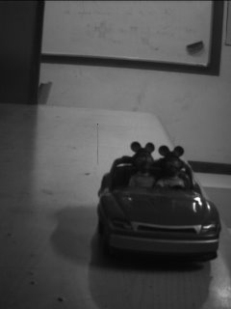

Fig 4. Reference image (L) and Traffic image (R)

The percentage match of the above traffic image with the reference image is 80 %.

# **BLOCK DIAGRAM**

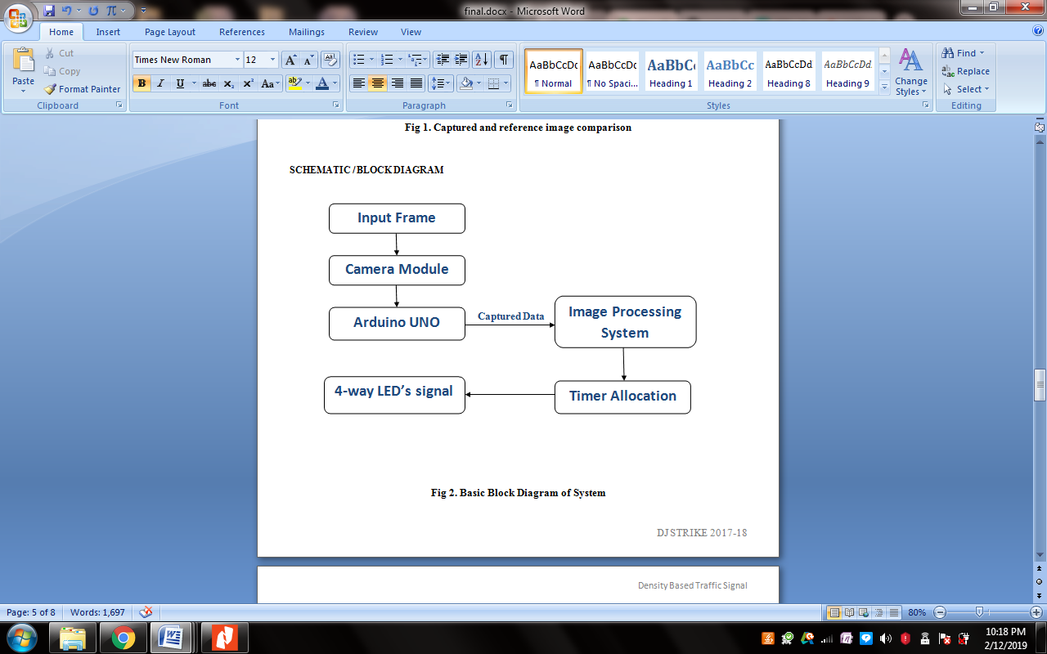

Fig 5. Basic Flow of the Project.

{Put the Timing allocation flow chart here}

Fig 6. Timer Allocation based on density.

# **FUTURE SCOPE**

In the coming future this project will have real industry applications as the image processing and density count mechanisms can help the city pre-plan the traffic management methodologies by studying the traffic statistics on particular routes and how this system can further be integrated with Artificial Intelligence systems so that the signals ahead can plan their signaling response based on traffic at the previous signal junctions for smoother traffic flow. Also help reduce manual labor especially in countries like India and also help the health-care vehicles like ambulances or even fire brigade vehicles to respond in time to casualties irrespective of the road traffic conditions.

# **CONCLUSION**

An efficient density based traffic control system is simulated and implemented which provides a good traffic control mechanism without time wastage. It is also a much better way of detecting the presence of vehicles on the road since it makes use of image data. So it surely operates much better than systems which rely on the metal content of the vehicles to detect their presence. Image processing techniques overcome the limitations of the all the traditional methods of traffic control. It eliminates the need for extra hardware and sensors. The use of multiple cameras will help to analyze and control traffic in a particular region. The proposed system outperforms the existing system in terms of accuracy and simplicity.

# **REFERENCES**

* Smart Control of Traffic Signal System using Image Processing by V. Parthasarathi, M. Surya, B. Akshay, K. Murali Silva and Shriram K. Vaudevan
* Traffic Density Measurement using Image Processing: An SVM approach by International Journal of Innovative Research in computer and Communication Engineering
* https://www.slideshare.net/louiseantonio58/image-processing-based-intelligent-traffic-control-systemmatlab-gui
* www.irjet.net
* www.researchgate.net

**IEEE conference templates contain guidance text for composing and formatting conference papers. Please ensure that all template text is removed from your conference paper prior to submission to the conference. Failure to remove template text from your paper may result in your paper not being published.**

We suggest that you use a text box to insert a graphic (which is ideally a 300 dpi TIFF or EPS file, with all fonts embedded) because, in an MSW document, this method is somewhat more stable than directly inserting a picture.

To have non-visible rules on your frame, use the MSWord “Format” pull-down menu, select Text Box > Colors and Lines to choose No Fill and No Line.